**Institute of Engineering & Management**

**Department of Computer Science & Engineering**

**Software Tools Laboratory for 2nd year 4th semester 2018**

**Code: CS 492**

**Date:** 31/01/18

**WEEK-2**

**Assignment-1**

**Problem Statement:** Write a program to demonstrate the idea of the message box function. Also describe the various attributes of message box function with suitable code snippet.

**Screen-Shot:**

**Form-1:**

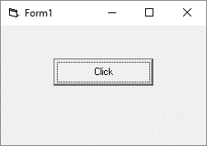

**Message Box:**

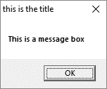

**Form Code:**

**For Form-1:**

Private Sub Command1_Click()  
Call MsgBox("This is a message box", vbOKOnly, "this is the title")  
End Sub

**Assignment-2**

**Problem Statement:** Write a program to demonstrate the idea of the input box function. Input a character through input box function and determine whether it is vowel, consonant or special character.

**Screen-Shot:**

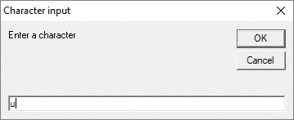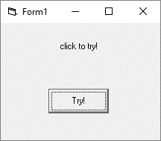**Form-1: Message Box:**

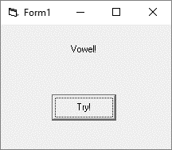After Clicking OK in Input Box:

**Form Code:**

**For Form-1:**

Private Sub Command1_Click()  
x = InputBox("Enter a character", "Character input")  
If Len(x) > 1 Or x = "" Then  
Label1.Caption = "Enter one character"  
Else v = Asc(x)  
If v >= 65 And v <= 90 Then  
If v = 65 Or v = 69 Or v = 73 Or v = 79 Or v = 85 Then  
Label1.Caption = "Vowel!"  
Else Label1.Caption = "Consonant!"  
End If  
ElseIf v >= 97 And v <= 122 Then  
If v = 97 Or v = 101 Or v = 105 Or v = 111 Or v = 117 Then  
Label1.Caption = "Vowel!"  
Else Label1.Caption = "Consonant!"  
End If  
Else  
Label1.Caption = "Special character!"  
End If  
End If  
End Sub

**Assignment-3**

**Problem Statement:** Write a program to demonstrate the idea of the checkbox control. Input some string with a text box. Put three check boxes captioned as: - a. block letter, b. small letter, c. normal case. On the form. The string case will be changed after clicking the appropriate checkbox.

**Screen-Shot:**

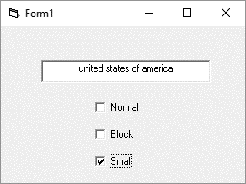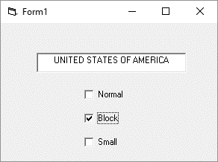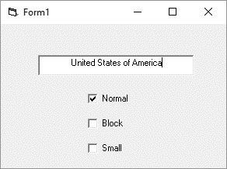 **Form-1:**

**Form Code:**

**For Form-1:**

Private Sub Check1_Click()  
If Check1.Value = 1 Then  
Check2.Value = 0  
Check3.Value = 0  
End If  
End Sub  
  
Private Sub Check2_Click()  
If Check2.Value = 1 Then  
Text1.Text = UCase(Text1.Text)  
Check1.Value = 0  
Check3.Value = 0  
End If  
End Sub  
  
Private Sub Check3_Click()  
If Check3.Value = 1 Then  
Text1.Text = LCase(Text1.Text)  
Check2.Value = 0  
Check1.Value = 0  
End If  
End Sub

**Assignment-4**

**Problem Statement:** Write a program to demonstrate the concept of the option button control. Input some string with a text box. Put two check boxes captioned as: - a. bold font, b. normal font. On the form. The string font will be changed either in bold or in normal after clicking the option button.

**Screen-Shot:**

**Form-1:**

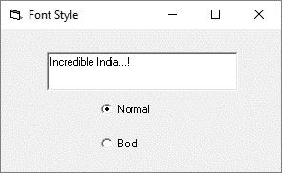 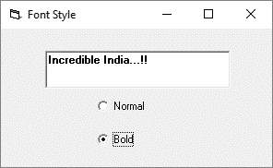

**Form Code:**

**For Form-1:**

Private Sub Option1_Click()  
If Option1.Value = True Then  
Text1.FontBold = False  
End If  
End Sub  
  
Private Sub Option2_Click()  
If Option2.Value = True Then  
Text1.FontBold = True  
End If  
End Sub